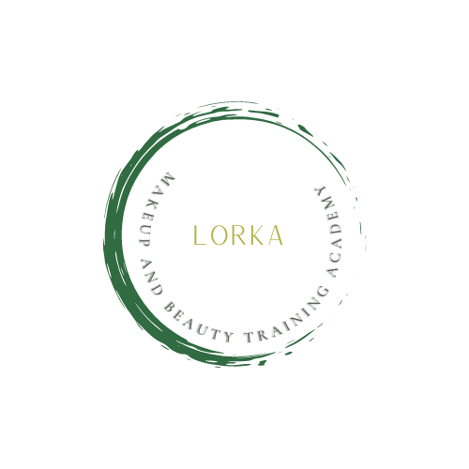

LEARNER COMPLAINTS PROCEDURE

It is the company’s policy to resolve as quickly and fairly as possible any complaint that is made by our learner.

Scope:

The Learners Complaints Procedure applies to complaints:

From Learners about their educational experience;

About a service provided by the Training Provider;

Concerning discrimination by Lorka Makeup and Beauty Training Academy on the grounds of gender, race, faith, age, disability or sexual orientation;

About the behaviour of a member of staff/self employed towards a Learner;

About the behaviour of a Learner or Learner;

From a Learner who believes that she or he has suffered an injustice as a result of action taken or not taken on behalf of the Training Provider.

The above list is not intended to be exhaustive and, where appropriate, complaints about other matters will be considered under the Learners Complaints Procedure.

Principles:

The principles, which underpin the Learners Complaints Procedure, are:

Learners will not suffer disadvantage as a consequence of making a genuine complaint;

At Lorka Makeup and Beauty training Academy we will seek to resolve complaints as quickly as possible within the available resources and to find resolutions which are reasonable and acceptable to all parties;

Learners will be allowed reasonable time to seek guidance and assistance in connection with any aspect of the complaints process;

All parties are expected to make reasonable efforts to resolve matters on an informal basis before moving to the formal stages of the process;

Any investigations undertaken as part of the formal complaints process will be conducted by individuals who are independent;

Learners have the right to be accompanied by a relative or friend, who is not acting in a legal capacity, at any meeting arranged to discuss the complaint;

All parties to a complaint will be kept informed at all stages of the progress of any investigations into the matters raised and will be informed in writing of the outcome of the process, the reasons for any decisions taken and any proposed remedies;

At Lorka Makeup and Beauty training Academy we will deal with complaints on a confidential basis but Learners should recognise that it may be necessary to disclose details of a complaint to other persons or organisations for the purposes of investigating the complaint and seeking an effective resolution;

Where matters are within the Training Provider’s control, it will ensure that appropriate remedial action is taken to resolve a complaint including addressing aspects of its operations, which are identified through the complaints process as requiring improvement. The above list is not intended to be exhaustive and, where appropriate, complaints about other matters will be considered under the Learner Complaints Procedure.

Responsibilities:

All parties involved in a complaint are expected to act courteously, fairly and reasonably towards each other and to comply with the requirements of the procedures by adhering to any deadlines, responding appropriately to any requests for information or attendance at meetings and undertaking any reasonable action required in pursuance of a satisfactory remedy. Lorka Makeup and Beauty Training Academy will investigate all complaints brought under the formal part of the procedure; however, it reserves the right to refuse to consider any learner complaints which are thought, after initial investigation, to be unreasonable, vexatious or malicious.

Process:

Stage 1: Discussion and Advice

It is very important to get early advice about problems. Often, this can resolve the matter quickly and informally. Normally, a learner would seek the advice of a member of Training Provider staff such as a Tutor, an Assessor or a member of the management team. The learner can expect to be given advice on how to proceed and on an appropriate course of action, advice about what would constitute an appropriate remedy, and an opportunity to consider whether there is indeed a complaint to be addressed. The learner will then be in a position to decide whether to proceed further, and how.

Stage 2: Informal Process

It is in the interest of the students that a complaint to be dealt with informally should be raised at the ‘local’ level as soon as possible. If there has been a delay the student should explain the reason. The student should if possible record the complaint in writing. The Learners should if possible raise the complaint directly with the person responsible for the matter. It may not always be easy to do this if the complaint is about the conduct of this person: if for some reason the learners cannot go direct to the person alone he or she should ask for someone else to be present, or should raise the matter with another person in the organisation concerned. If possible a suitable solution will be agreed and implemented, to solve the problem. If the learner is dissatisfied with the outcome of such an informal process, he or she may consider whether to raise the matter formally through Stage 3.

Stage 3: Formal Process

Learners must exhaust informal routes before making a formal complaint, or give a good reason for not doing so. A good reason might be that the problem is particularly serious, or that when it was raised informally there was refusal to deal with it. Informal processes are suitable for dealing with many problems, but if a complaint includes very serious allegations, and especially where a person complained against must have an opportunity to give his or her side of the matter, it may be necessary to refer straight to Stage 3. If informal routes seem not to have been exhausted a formal complaint may be referred to informal resolution. A learner wishing to make a formal complaint must do so in writing. The written statement initiates the formal process and must include a description of what has happened to give rise to the complaint including dates, times, and other details. It is necessary to show that something has gone wrong in the discharge of a Centre duty towards the learner, and that the learner had suffered as a result. The complaint should be addressed to the Centre Director’s Kara Byrne or Lorraine Bourke Byrne

Within 15 working days, the Centre Director’s Kara Byrne and Lorraine Bourke Byrne –will review the complaint and the associated evidence. Further evidence may be requested at this stage. The outcome of the review will find either:

That there are no grounds for taking the matter further. If this is the case, the Training Provider will advise the learner accordingly in writing;

Or

That there are grounds for consideration and further investigation, where appropriate. If this is the case, an independent Learner Complaints Panel will be convened to hear the complaint.

The Learners Complaints Panel will consist of the Managing Director and an educator who will Chair the hearing, The learner will be invited to attend the hearing. The proceedings and outcome of the hearing will be minuted. The learner will have the right to be accompanied by a representative. The role of this person is to support and advise the learners. Where appropriate the representative may speak in support of the student however, it is expected that the learner will speak for him/herself during the hearing.

Completion of Procedures:

The outcome of the hearing, including details of any remedies proposed, will be sent in writing to all parties within 10 working days of the hearing.

Remedies:

Remedies for complaints include, but are not limited to, an apology, alterations to a process or to a service provided by the Training Provider and, exceptionally, compensation for loss or damage suffered. The Training Provider seeks to ensure that any remedies proposed are reasonable and appropriate to the nature and circumstances of the complaint.

Contact Information

Kara Byrne /Lorraine Bourke Byrne

Eaton House Unit 2

Rathcoole

D24X3F1

Email: [info@lorkamakeupandbeautytraining.ie](mailto:info@lorkamakeupandbeautytraining.ie)

Phone